**Exercise**

**Q1. -** Problem Statement: There can be multiple customers, who can place multiple orders on the site. Now a sales person can handle these orders will distribute into multiple sales persons (One order will be assign to one salesperson only). So a sales person can have multiple orders of multiple customers.

**Ans.**- we can create database for the situation or above statements using “ CREATE DATABASE database_name”;

In this DB there are customers, order and salespersons tables.

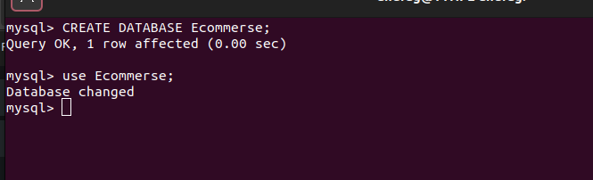

**Q2. -** Design Schema.

**Ans.** - schema contains three tables named Customers,Orders,Sales and columns in these tables are:-

Customers(cust_id(primary) , Fname , Name)

Orders(order_id(primary) , cust_id(F.key) , sales_id(F.key) , order_details)

Sales(sales_id(primary) , person_name)

Relation in customer to order is one to many as one customer can place many orders. sales to orders is one to one as one salesperson assigned for one order.

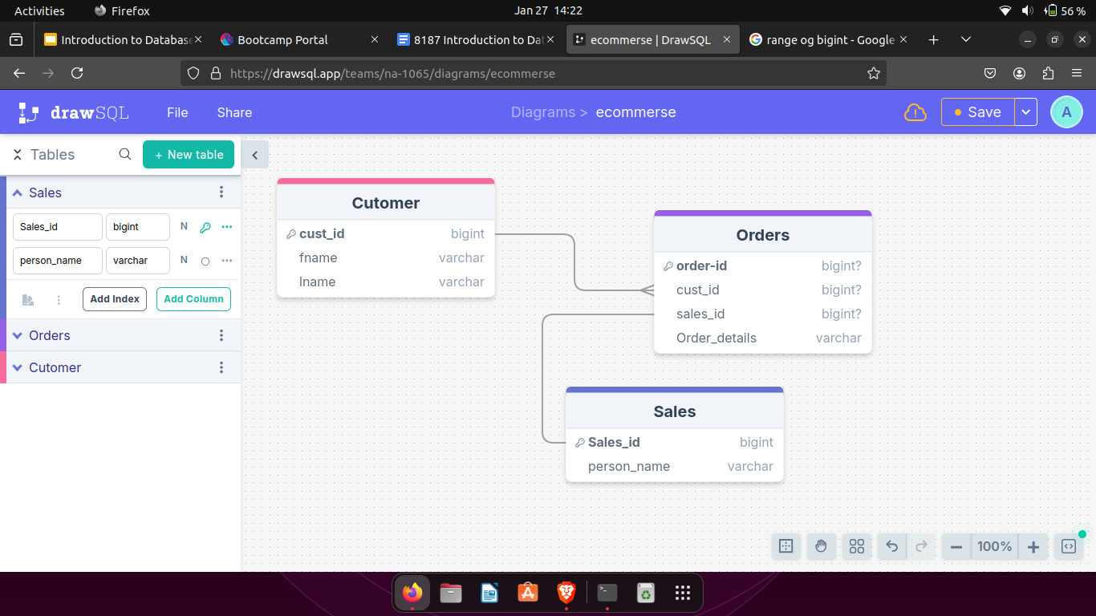

**Q3.** - Create Tables

**Ans.** - tables created using CREATE TABLE tablename command on mysql and give their attributes inside ( column1 (primary key if any), column2 , ….. ) along with data types of each column in the table.

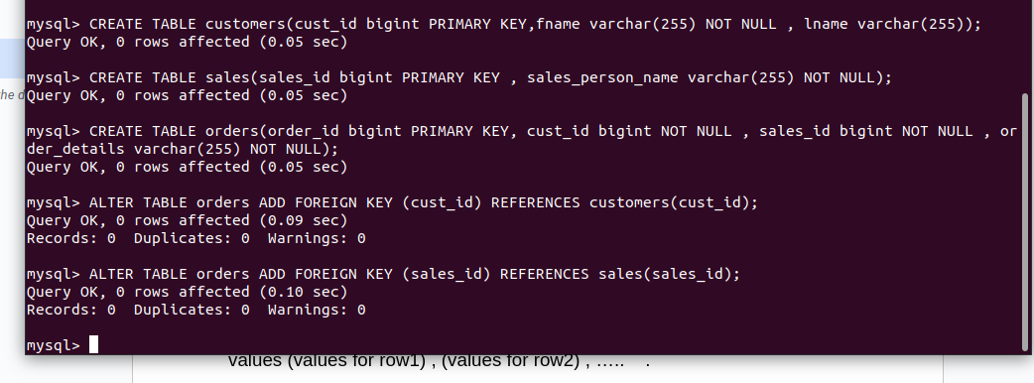

**Q4.** - Insert sample data

**Ans.** - Data to the tables inserted using INSERT INTO tablename command the (column names to which data will be given separated by ‘,’) values (values for row1) , (values for row2) , ….. .

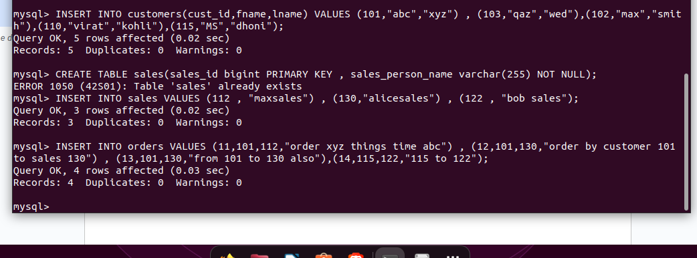

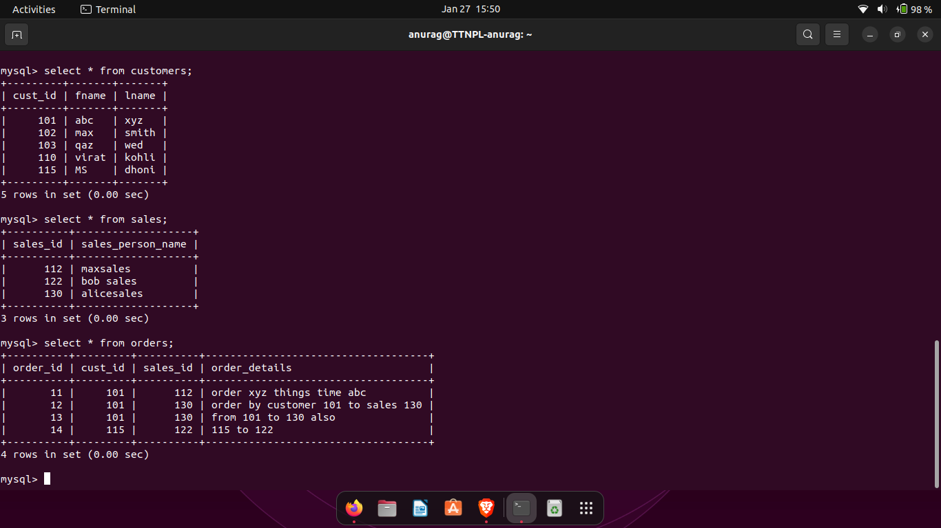

**Q5.** - Find the sales person who has multiple orders.

**Ans.** - we can find sales persons who have more than 1 orders using nested queries in which we insert internal query which groups rows basis on sales_id and output those rows having count of similar sales_id is greater than 1 which goes as input to external query which on the basis of sales_id gives rows consisting corresponding person name.

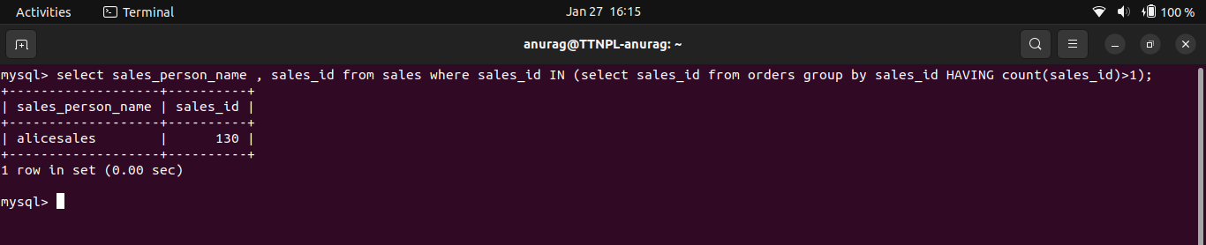

**Q6.** - Find the all sales person details along with order details

**Ans.** - as we have foreign key in orders table reference to sales id in sales table thus we can easily find the sales person details and their order details using inner join . It lists all the sales persons and their orders with details.

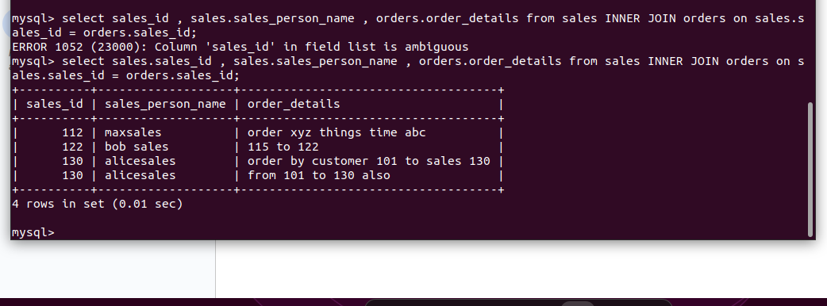

Q7. - Create index

**Ans.** - Index is a kind of structure that is used for efficient data retrieval and searching. We can create an index using ‘Create INDEX index_*name on table*name(column_name…)’.

Ex - CREATE INDEX cust_index ON customers(fname);

now if we search for a customer name in table it directly look in the index instead of searching whole table row wise thus it is efficient to perform query.

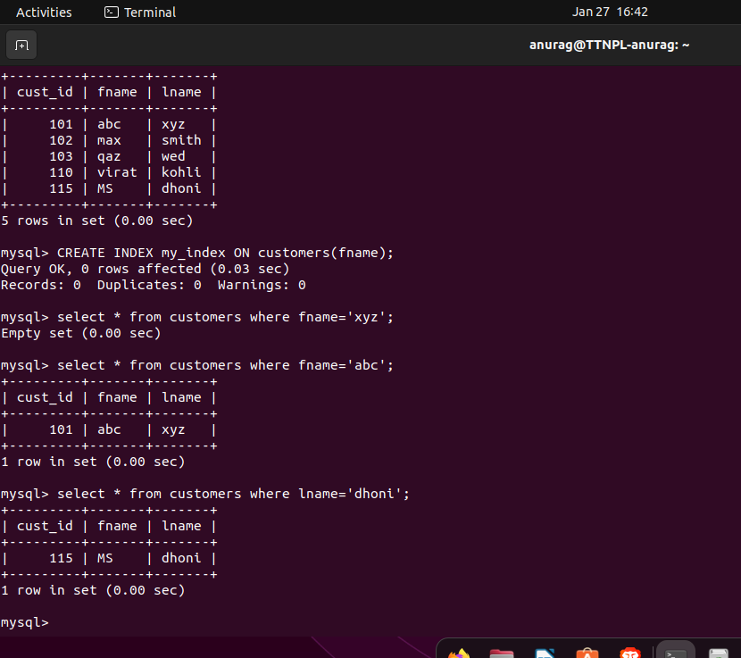

**Q8.** - How to show index on a table

**Ans.** - index created in a table can be shown by using “SHOW my_index FROM table_name;”.

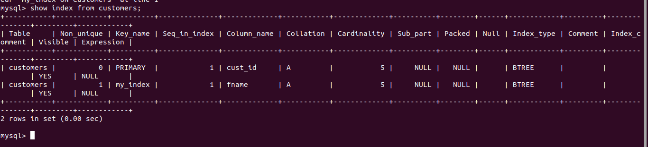

**Q9.** - Find the order number, sale person name, along with the customer to whom that order belongs to

**Ans.** - we can find the details from multiple tables using join upon multiple tables from foreign key in one table to primary key in other table as -

select orders.order_id , sales.sales_person_name , customers.fname from orders join sales on sales.sales_id = orders.sales_id join customers on customers.cust_id = orders.cust_id ;

